Waise Pay: An AI-Driven Solution to Manage Leisure Spending
Enhancing Financial Decision-Making Through Gamified AI Tools.

Tejaswini J. Khedkar,
Pace University, tk35751n@pace.edu
Diksha Jain,
Pace University, dj06495n@pace.edu
Anandu Kumar,
Pace University, ak2341n@pace.edu
This case study explores the development of a budgeting app that is aimed to reducing impulsive spending and assisting users in managing their leisure expenses. Through user research involving working professionals and international students, we identified user needs. The research revealed that users often struggle with overspending on leisure activities due to poor budgeting decisions, lack of personalized guidance, and motivation to save money.
We designed a solution with AI-driven features to provide weekly budgeting recommendations and a real-time expense impact analysis. Usability testing with paper and high-fidelity prototypes helped identify gaps, such as time-consuming manual inputs and a lack of tablet-friendly interfaces that lead to design refinements. The final prototype offers predictive analytics, automated budgeting with categories, and insights for users.
CCS CONCEPTS • Human-Centered Computing → User-Centered Design • Information Systems → Decision Support Systems • Applied Computing → Personal Finance
Additional Keywords and Phrases: Impulsive spending, leisure expenses, AI-driven budgeting, predictive analytics, personal finance management, gamified budgeting tools.
- Introduction
In the today’s financial landscape, budget management has emerged as a critical skill, yet many individuals struggle with impulsive spending, particularly on leisure expenses. This user behavioural pattern often leads to financial instability, undermining both short-term and long-term financial goals. Existing budgeting tools provide basic analytics but they fall short of offering personalized insights to individual spending pattern.
This paper introduces Waise Pay, a mobile application specifically designed to address this gap by leveraging artificial intelligence(AI) to personalize finance management. Waise Pay generates weekly categorized budgets, and provides real-time spending forecasting to enable informed decision-making. By integrating gamification and AI-driven predictive analytics, the app offers intuitive and engaging solution to mitigate impulsive spending and promote financial freedom.
Through user-centric design and a robust technological integration, Waise Pay not only simplifies expense tracking but also empowers users to achieve their short-term financial goals. This paper delves into the app’s development process, from identifying user pain points to creating innovative solutions, and evaluate its potential to transform how individuals can approach budgeting and expenditure management.
RELATED WORKS: SPENDING PATTERN IN AMERICA
We conducted a literature review to understand potential user groups and their behaviours related to budgeting and spending. This review included six research papers that provided an in-depth understanding of financial habits, challenges, and spending patterns. The goal was to uncover insights that could inform the design of a solution tailored to user needs.
  - Trends and Statistics
The survey found that 83% of Americans say they overspend. Many use credit cards to cover it. Adults aged 18 and older found that around three-quarters (74%) of Americans have a monthly budget, yet 59% are not tracking their spending.
  - Impulsive Spending
Impulsive spending is characterized by unplanned purchases often driven by psychological and situational factors. It often arises from materialism, where individuals link self-worth to ownership, and from impulsivity, which leads to unplanned purchases that exceed the budgets. Self-control challenges play a major role, particularly when individuals are mentally exhausted, leading to reduced decision-making capabilities. Instant gratification and a failure to monitor this behaviour are additional challenges. Many consumers prioritize immediate desires over long-term financial goals, further contributing in impulsive spending.
- User research
We conducted user research to delve deeper into the user pain points experienced by our target users, building on the foundation laid by our literature review. By directly engaging with individuals, we aimed to uncover insights that guided our design solutions.
Our target users were identified through the literature review process. We focused on two target users: working professionals from America aged 20 to 45, and international students aged 20 to 35. These groups were chosen because they represent the segments with distinct financial challenges and opportunities for improvement.
  - Research Questions
Our research was guided by the following key questions:
- How are users are planning their budget?
- What measures do users take to prevent overspending?
- What is the impact of impulsive spending on short-term and long-term goals?
  - Interview Structure

During the interviews, participants were asked descriptive questions. We wanted to gather information about their spending behaviours, and financial goals. Opinion-based questions provided insight into their attitudes, and emotional responses to financial management.

The research was structured around two key methods: interviews and contextual inquiries. During the interviews, participants were asked descriptive questions to gather information about their budgeting processes, spending behaviours, and financial goals. Opinion-based questions provided insight into their beliefs, attitudes, and emotional responses to financial management.

In addition to interviews, we conducted contextual inquiry to observe participants in real-life situations. By observing participants in their natural environment, we could identify patterns, inconsistencies, and potential pain points that might not have surfaced through user interviews.
- research findings
Through our user research we found out that individuals categorize their monthly expenses into two types: fixed and variable. Fixed expenses include necessities such as rent, groceries, and daily needs, while variable expenses goes in leisure activities, entertainment, and hobbies. While participants generally manage their fixed expenses effectively, they often struggle with overspending in variable expenses.
The primary reasons for this overspending are a lack of personalized guidance, poor budgeting decisions, and inconsistency in financial goals. Without tailored financial advice, users often feel unsure about how to allocate their funds effectively for variable expenses. Poor budgeting decisions arise from inadequate planning, leading to frequent overspending. Additionally, users struggle with maintaining consistency in tracking their expenses, making it difficult to identify patterns and regulate their spending habits. These insights highlight the need for a solution that provides personalized guidance, supports budgeting, and encourages consistent financial management.
  - Pain Point
Due to impulsive spending, users procrastinate to fulfil their desired financial goals.
- user need
Users expressed a strong desire to have better control over their expenses, particularly variable costs like leisure and entertainment. Many users struggle with monitoring and limiting these discretionary expenditures, which often lead to overspending. By gaining a clear understanding of their spending patterns, users hope to achieve greater financial discipline and feel more secure in managing their finances effectively.
Another need is the ability to make informed financial decisions. Many users lack personalized guidance that aligns with their unique financial circumstances. This often results in impulsive spending. They require tools that provide actionable insights, such as categorizing expenses and offering tailored recommendations, to help them align their spending with their short-term and long-term objectives.
It is important for users for effective budgeting assistance. While many attempt to create monthly budgets, they face challenges in maintaining consistency in managing unexpected expenses. Tools that simplify the process with gamified features like automated expense tracking, real-time alerts, and spending analytics would help users stick to their budgets and achieve better financial outcomes.
- Interface design and evaluation
The solution is a budgeting app designed to help users manage their leisure expenses to prevent impulsive spending. It offers AI-powered guidance and expense tracking through analytics. It enables users to stay within their budget while making informed decisions on their unique financial priorities.
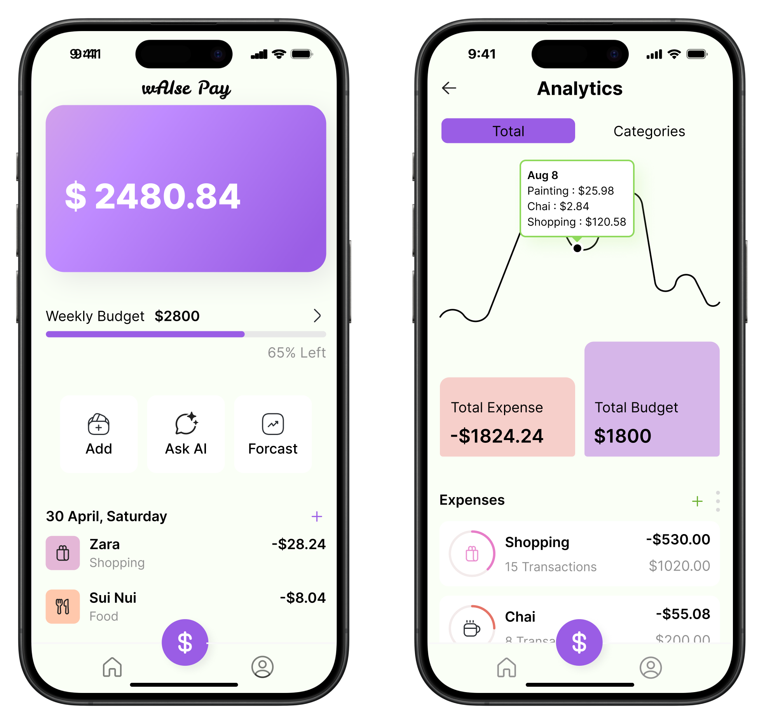
Figure 1: Home Screen and Analytics Screen

  - Feature Breakdown
Users have AI assistance to budget their leisure expenses, track their spending to make informed financial decisions. The AI feature provide users with personalized advice on financial concerns, helping them stay on track with their spending decision. Users receive a weekly budget plan powered by AI and a detailed breakdown of their budget with personalized categories, ensuring they stay informed with their financial management.
The app's main feature is the generation of a weekly budget based on user’s income and spending habits. Using AI-driven predictive analytics, the app analyses past financial data, helping users understand how their previous expenses affect their financial standing. This personalized budget is adjusted weekly, providing users with clear guidelines on how to allocate their funds while considering both fixed and variable expenses. The goal is to assist users in maintaining a balanced budget that reflects their real financial situation, empowering them to make informed decisions.
Another key feature of the app addresses impulsive spending. When a user is about to make an impulsive purchase, user can ask the app to input the purchase value and receive a analysis of the impact on their weekly budget. This feature help users to visualize how small, spontaneous expenses might affect their overall financial goals. It is a real-time check, offering insights on whether the purchase will cause a potential overspend, thus encouraging a thoughtful spending decisions before making impulsive purchases.
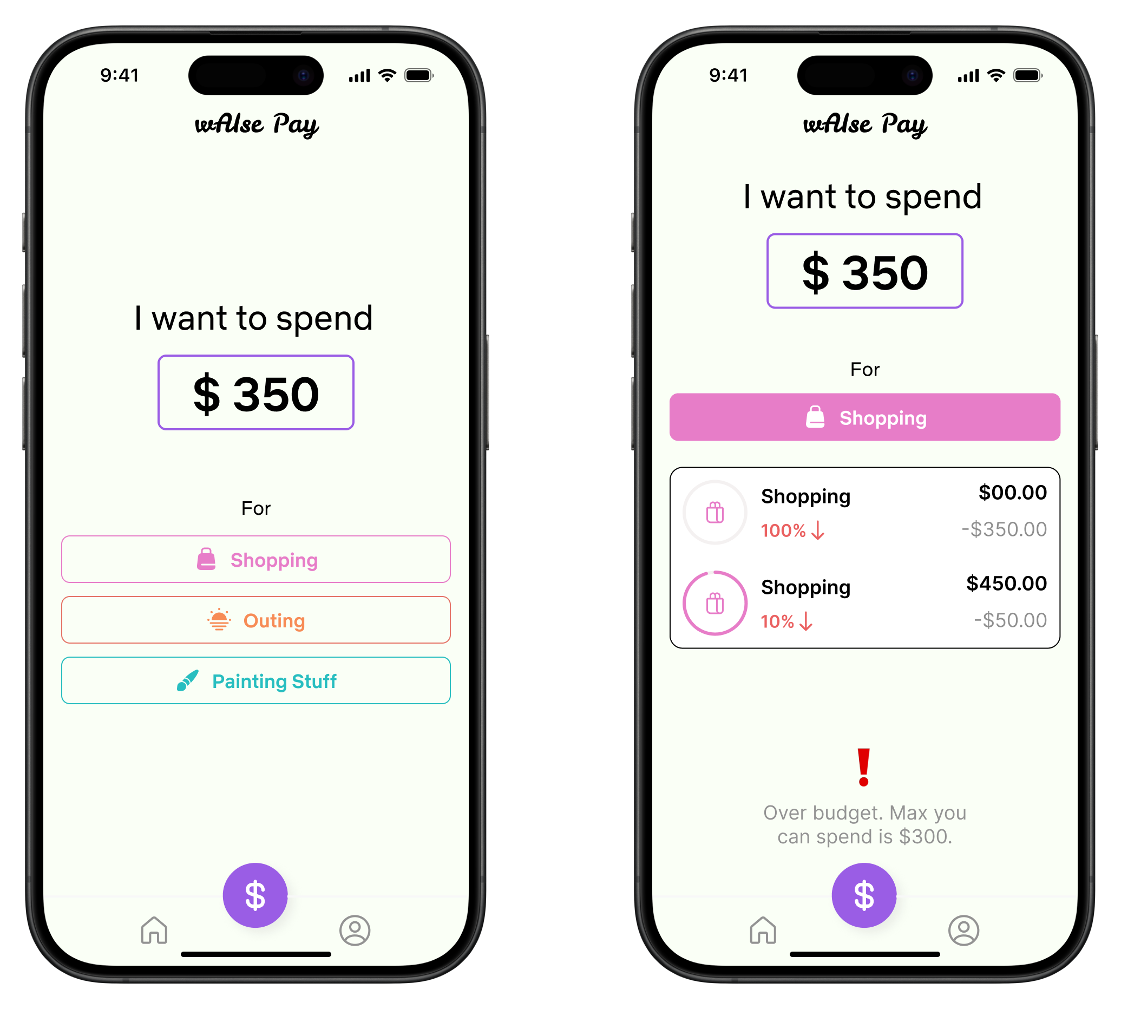
Figure 2: AI Budget Forecast Input Screen and AI Budget Forecast Results Screen

  - Usability Testing
Usability testing was a critical step in refining the application to ensure it met user needs. We conducted usability studies with five participants using low fidelity wireframes first. This initial stage was aimed to identify potential loopholes in the app’s user flow, specifically focusing on the "AI Assistance" and "Add Money" feature. We revealed two significant gaps: users found it cumbersome to input money manually and provide commands through the Chabot, with 4 out of 5 participants stating that this process was time-consuming and prone to errors due to the AI Chabot’s potential limitations in understanding commands. To address this, we changed the screen allowing users to input amounts directly and receive a forecast of their budget, making the process quicker and intuitive.

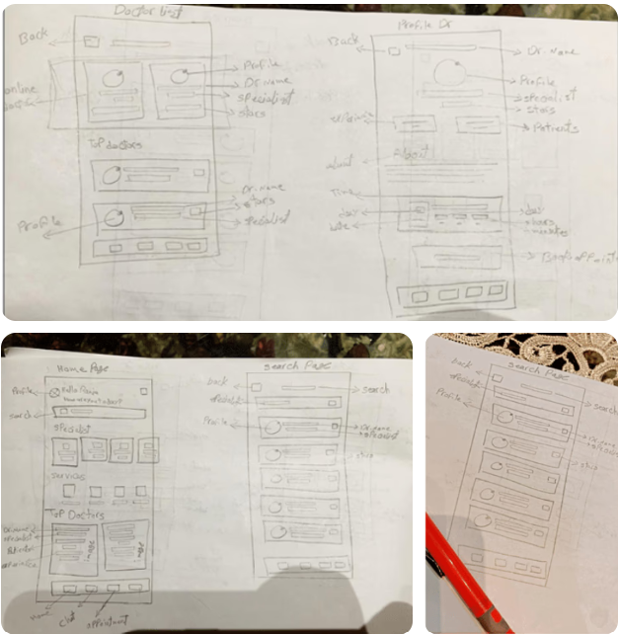
Figure 3: Hypothesis For Usability Testing

Another key insight was highlighted around the importance of device compatibility. Three out of five users mentioned that they often use iPads or tablets during their free time when impulsive spending is more likely to take place. This feedback led us to design a tablet-compatible version of WAISE PAY, enabling users to access budgeting features seamlessly through their preferred devices.
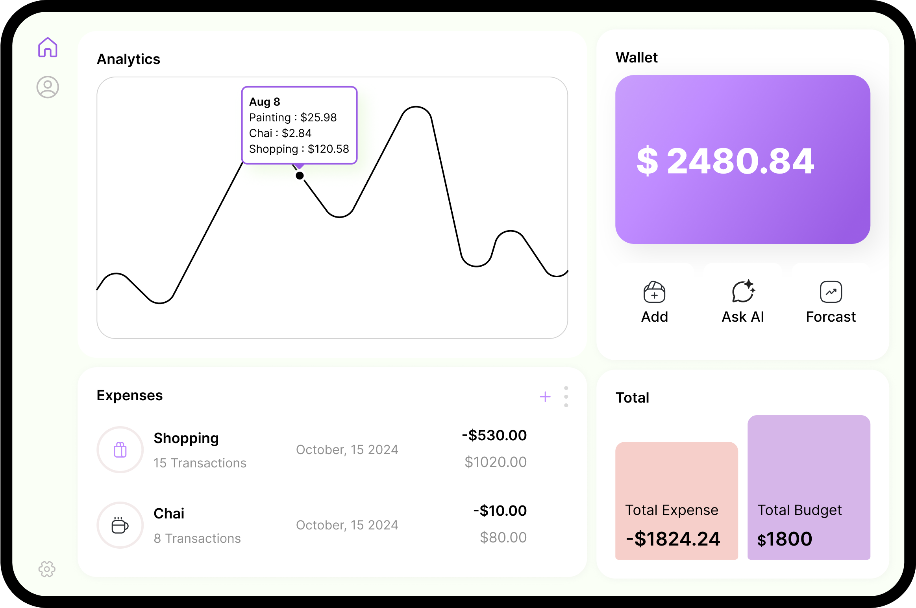
Figure 4: High-Fidelity Prototype of a Tablet Screen

These modifications were integrated into the design, leading to the creation of high-fidelity prototypes for WAISE PAY. In the next phase of testing, we evaluated these prototypes with five different participants. Two of these users were from different demographics, as we aimed to ensure scalability and inclusivity. This approach was critical in validating that the app could cater to the diverse user needs and preferences while maintaining its core functionality.
By addressing specific user pain points and incorporating changes based on real-world scenarios, we ensured the final product was both user-friendly and gamified, ultimately enhancing its effectiveness in helping users manage their leisure expenses
  - How the application works
The app leverages predictive analytics to analyze user’s past spending habits, income sources, and typical monthly expenditure. By processing this data, the AI generates forecasts of future expenses by providing users with a weekly budget of their anticipated spending. This feature enables users to plan their budgets effectively and encouraging proactive decision-making.
To enhance financial clarity, the AI categorizes transactions into tailored spending categories. Through detailed analytics, users receive a detailed breakdown of their expenses, helping them understand where their money is going. This categorization is crucial for identifying the patterns and ensuring users stay informed about their financial pattern.
The app also provides actionable insights by focusing on areas of potential overspending. AI-driven recommendations guide the users on how to adjust their spending habits, ensuring a balanced weekly budget. These insights empower users to take control of their finances, avoid impulsive spending, and make informed decisions that align with their financial goals.
- LIMITATIONS
One limitation of our prototype was the inability to test the efficiency of the AI system we incorporated. Since we conducted a cognitive walkthrough, the focus remained on evaluating the usability and human-interface of the mobile app rather than the functionality of the AI in our app.
Another limitation was the missing of actual data integration. The prototype solely relied on hypothetical financial data to test the cognitive aspects of the mobile app. Without real user data, it was not possible to simulate actual financial transactions, which restricted us to evaluate the predictive analytics feature of the app.
- DISCUSSION
The discussion highlight the potential of AI-driven predictive analytics through WAISE PAY app helping users manage their leisure expenses and avoid impulsive purchases. Through user-centered design and feedback, the app was refined several times to offer personalized guidance, expense categorization, and actionable insights. However, limitations such as reliance on hypothetical data and an incomplete evaluation of AI efficiency restrict the ability to fully assess the capabilities of WAISE PAY.
- CONCLUSION
The app does not aim to directly change the behaviour of the user but instead focuses on creating awareness around the impact of impulsive spending on users' weekly budget. By providing users with predictive insights, budget forecasting, expense categorization, and AI-driven recommendations, it encourages financial awareness and informed decision-making.
The app serves as a tool for users to reflect on their unnecessary spending habits and understand how small, impulsive purchases can affect their overall financial goals. Through this awareness, users are empowered to make take thoughtful decisions regarding their leisure expense.
- FUTURE SCOPE
Future development should focus on integrating real user data for testing the AI's performance. Additionally, attention to data security, inclusivity, and cultural adaptation will be essential for scaling the app and meeting diverse user needs around the glob.
- Citing Related Work
This section cites a variety of journal [1, 2, 3], conference [4], and technical report [5] articles to illustrate how they appear in the references section. For example, the paper "Link Budgeting and Interference Management for UAV Networks in 5G and Beyond" [1] discusses UAV networks in advanced communication systems. Similarly, "Evaluating the application of NLP tools in mainstream participatory budgeting processes in Scotland" [2] examines how natural language processing tools enhance budgeting participation. Additionally, "An Analysis of Material Need and Development Digital Media in Learning Budgeting Accounting Study Program Undiksha" [3] explores the integration of digital media in accounting and budgeting education programs.
REFERENCES
- Henry Michaelson. Link Budgeting and Interference Management for UAV Networks in 5G and Beyond. In Proceedings of the ACM International Conference on Computing and Communication Systems (ICCCS), 2022. ACM Digital Library. DOI: 10.1145/3516875.3516948.
- Jonathan Davies, Miguel Arana-Catania, Rob Procter, Felix-Anselm van Lier, and Yulan He. Evaluating the application of NLP tools in mainstream participatory budgeting processes in Scotland. In Proceedings of the 2022 ACM Conference on Supporting Groupwork (GROUP), 2022. ACM Digital Library. DOI: 10.1145/3494193.3494242.
- Ni Luh Gede Erni Sulindawati, I Wayan Lasmawan, I Nyoman Natajaya, and Gede Adi Yuniarta. An Analysis of Material Need and Development Digital Media in Learning Budgeting Accounting Study Program Undiksha. In Proceedings of the 2023 ACM International Conference on Education and Multimedia Technology (ICEMT), 2023. ACM Digital Library. DOI: 10.1145/3565287.3617627.

